APP LAUNCH PLAN

When launching the app I would include a description of the app’s functionality and provide screen shots of the different screens. This may look like:

**Description:**

The Event Tracker App is a simplified app to organize your calendar and keep track of your upcoming events. Whether you are a student trying to keep track of projects and due dates, or a professional who needs to have your meetings organized, or a parent who needs to keep track of busy kids, Event Tracker can help you stay organized and not miss anything.

**Icon:**

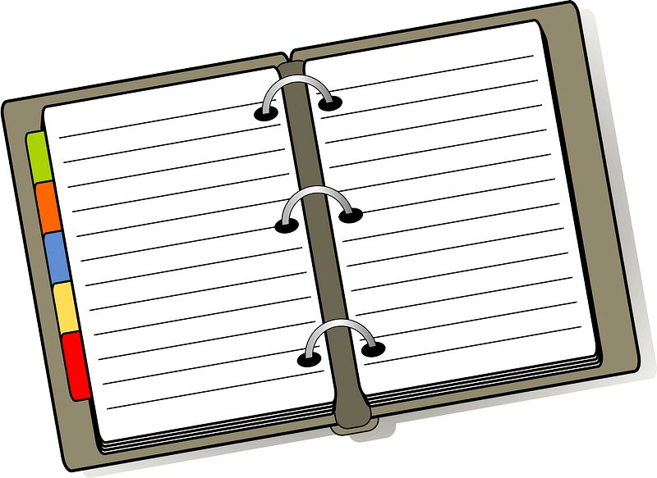

This is the Icon I would use as it is consistent with the background in the app with the Navy Blue color. It also has the app logo of the planner on it as well.

This app was developed on Android 9 API 28 Which would run on approximately 86.6% of devices as of May 6, 2023. Prior to actually launching the app on the Google Play store I would need to make the app targets Android 13 API 33 at a minimum to be discoverable on the Play store.

The Event Tracker app will only need to send an SMS for upcoming events, therefore the only permission that would be asked is to allow the app to send an SMS. This can be enabled or disabled by the user at any time by clicking the SMS button from the main page and choosing to allow or disallow SMS messaging.

As for Monetizing the app, I would offer the app for free with ads, but for a one time payment, the user could use the app ad free. There is also the possibility for in the future to provide different color themes to add some customization to the app for the user, where the free version would only have access to certain themes, and if the user pays the one time fee more themes are available to choose from.

Citations:

Belinski, E. (n.d.). *Android API levels*. <https://apilevels.com/>

*Target API level requirements for Google Play apps - Play Console Help*. (n.d.). https://support.google.com/googleplay/android-developer/answer/11926878?hl=en#:~:text=When%20you%20publish%20a%20new,is%20compliant%20with%20this%20policy.